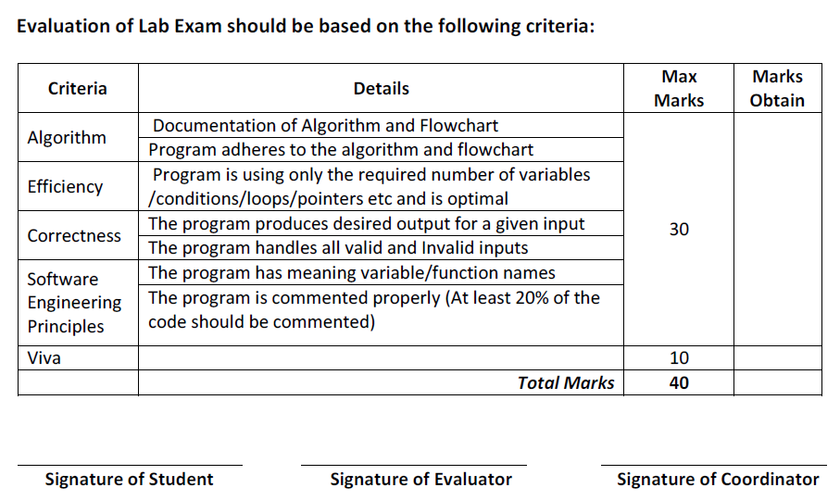
CENTRE FOR DEVELOPMENT OF ADVANCE COMPUTING
Advance Computing Training School

Course Name: PG Diploma in Advanced Computing Batch: March 2024
Module Name: J2EE Date: 03/06/2024
Student Name: Max Marks: 40
Roll No: Duration:
Set - 1

Q1.
Solve any One Problem on 1 and 2
============================

Problem Definition 1 a:

Create a Hibernate based application that is used to maintain data about Books as per the following:
- Book Id (Numeric)
- Title (Character Based)
- Author (Character Based)
- Price (Numeric)

Write Java programs as per the following:
Program 1:
Accept user input for a book data and store it into the database.

Program 2:
Accept Author Name and Price range and display those books matching with the Author Name and Price range.

Display appropriate message if no data found.

Note: Handle Mapping and Configuration without XML

Problem Definition 1 b:

Create a Spring based application that is used to configure Beans holding an information about Book as mentioned in Problem Definition 1.
(DO NOT COPY AND PASTE THE CLASS. CREATE A SEPARATE ONE)

The application must configure 2 beans as per the following:
- A bean of type Book holding Book information
- A bean of type java.util.List holding several Books.

Write a Java program as per the following:
- Load both the beans
- Check whether the loaded Book bean is available within the loaded List bean or not and display the appropriate message.
Note:
Handle Java Based Configuration
Implement LAZY loading for both the beans

Problem Definition 2:
Create a REST API that allows users to manage data about Pre-Owned Cars for SALE.

Car Information:
ID - Numeric
Make - Character Based
Model - Character Based
Price - Numeric
Year - Numeric

End-Points Description:

GET /cars-api
Loads and displays all the Cars data in JSON format

GET /cars-api/ID
Loads and displays data about a specific car against its ID

GET /cars-api/minPrice/maxPrice
Loads and displays data about specific cars with matching price range

GET /cars-api/make/year
Loads and displays data about specific cars with matching make and year

GET /cars-api/make
Loads and displays data about specific cars with matching make

POST /car-api
Adds a new car for SALE

Note:
Use In-Memory Collection to as a persistent store
Use Layered Architecture -Controller – Service – Repository
Use 8989 Port Number for the Embedded Tomcat

